**Ideation Phase**

**Define the Problem Statements**

|  |  |
| --- | --- |
| Date | 19 September 2022 |
| Team ID | PNT2022TMID32725 |
| Project Name | HAZARDOUS AREA MONITORING FOR INDUSTRIAL PLANT POWERED BY IOT |
| Maximum Marks | 2 Marks |

**Customer Problem Statement:**

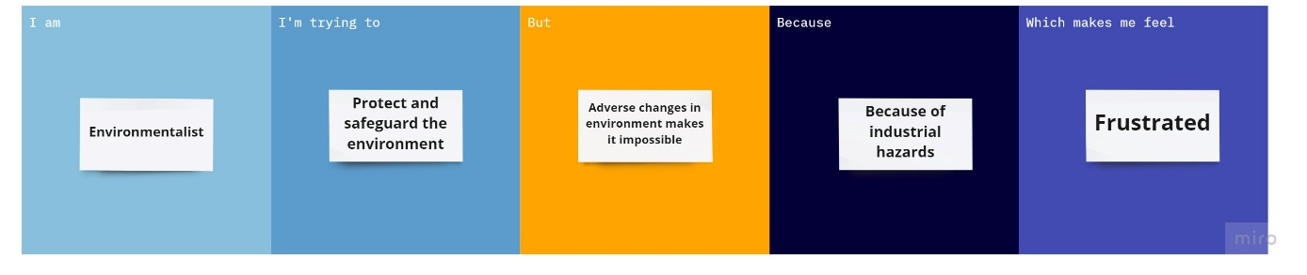

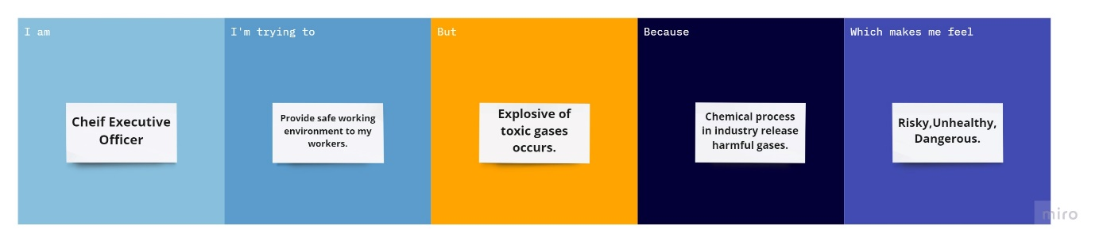

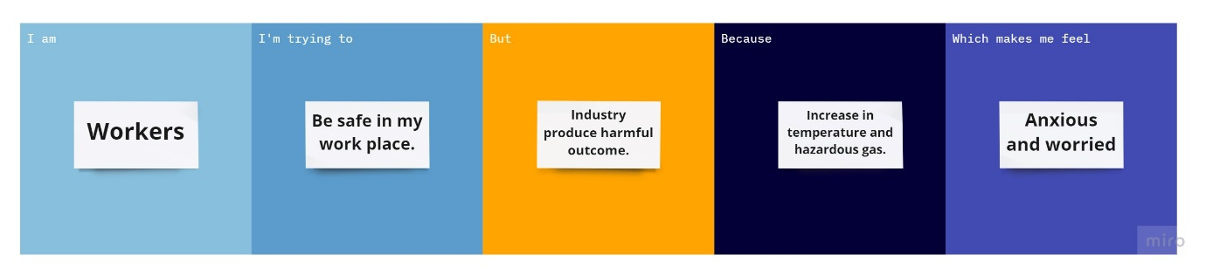

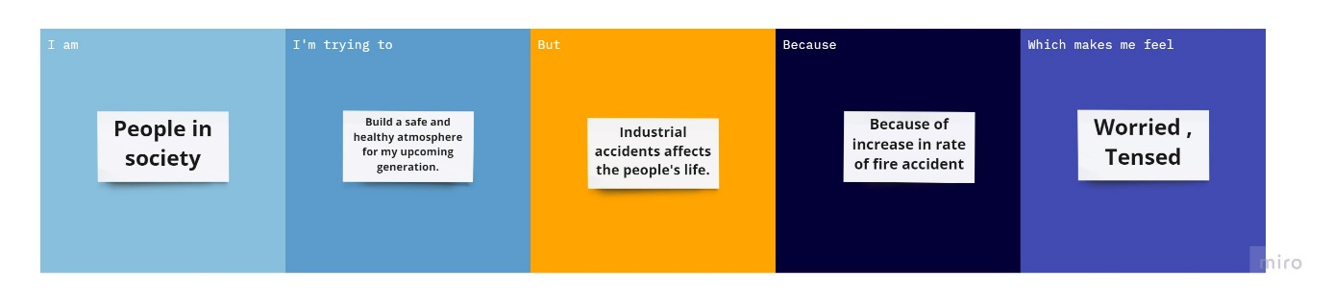

**SUBMITTED BY:**

AASHIKAA.R.MOHAN(813819106003)

DHARSHINI.K(813819106023)

FERDINA.C(813819106027)

HARINI.M(813819106031)